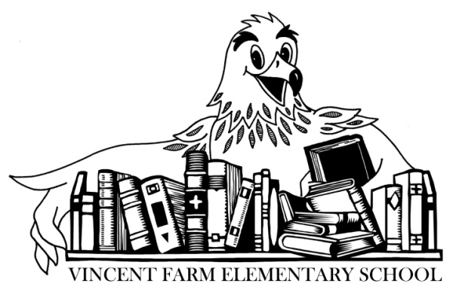
Fifth Grade Supply List

The following lists are supply items that will likely be needed by the student during the school year:
- 36 pre-sharpened #2 yellow pencils (no mechanical pencils)
- 1 box of sharpened colored pencils
- 2 yellow highlighters
- 4 marble composition books
- 2 packs of wide-ruled loose leaf paper
- 6 pocket folders
- 1 pencil pouch (no boxes please)
- 1 pack of sticky notes
- 3 glue sticks
- 1 pair of scissors
- 1 bookbag
- Art Class: 1 art shirt, apron, or smock, it can be an adult’s old t-shirt, something oversized
- Wired headset with microphone in a labeled bag (Please no wireless headphones)

Families may donate the following school supplies:
- hand sanitizer
- dry erase markers (thick)
- tissues
- disinfectant wipes
- re-sealable baggies (quart, or gallon)
Students should bring all supplies by the first day of school.
Please label all supplies with your child’s name.
2021-2022

