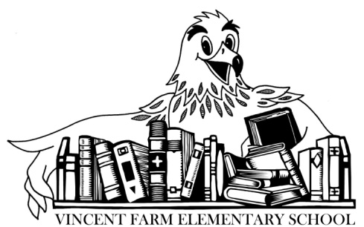
Kindergarten
Supply List

The following lists are supply items that will likely be needed by the student during the first half of the school year:
- A backpack to be worn to school daily. (No backpacks with wheels. No miniature backpacks please. Please make certain that the backpack is marked with your child’s name.)
- A bag of extra clothing to be kept at school. (This will be used in case of a bathroom accident or spilled milk/juice. Please make certain that the bag, and all clothing, is marked with your child’s name.)
- 1 set of headphones (not wireless/no earbuds) Labeled with your child’s name.
The following items do not need to be labeled with your child’s name:
- 6 packs of Crayola crayons (24 count)
- 24 Elmer’s glue sticks (not liquid)
- 12 pack of yellow number 2 pencils (sharpened)
- 5 pack of primary pencils (thick)
- 4 primary composition books (half page for picture/half page lines)
- 2 thick, plastic pocket folders (with metal prongs)
- 2 folders of your child’s choice (Plastic)
- 4 packs of washable markers (2 pack classic, 2 pack other colors)
- 4 packs of thin, black dry erase markers
- 2 highlighters
- 2 set of Crayola watercolors
- 3 pack index cards

Families may donate the following school supplies:
- Ziploc bags (snack, sandwich, quart and gallon sizes)
- tissues
- thin, black dry erase markers
- baby wipes
- Lysol wipes/Hand Sanitizer
- Paper plates
2020/21

